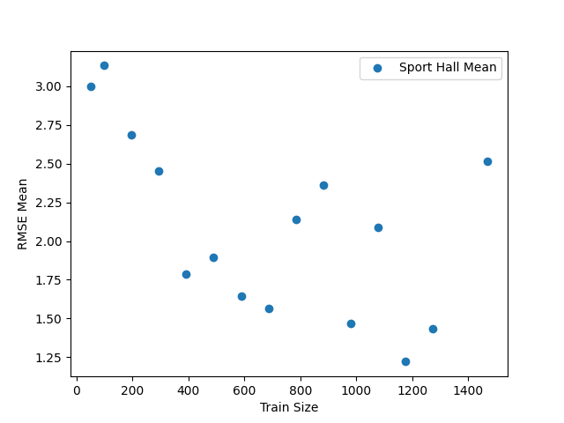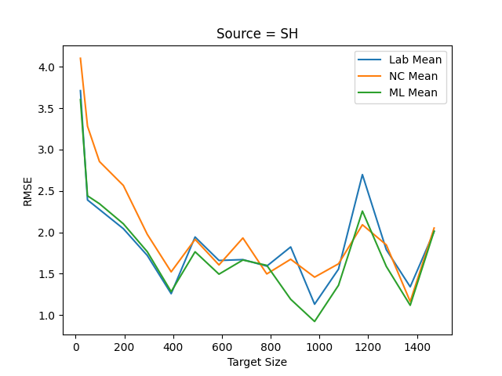

Constant:

* Model
* Training Data
* Source Size = 1470

Testing:

* Target size and recording RMSE result.

Result:

* A point that had a drop is at 392 with target sizes. The drop is evident will all different locations. However, the RMSE remains big even as the size increases. This may be the result of the source values test.

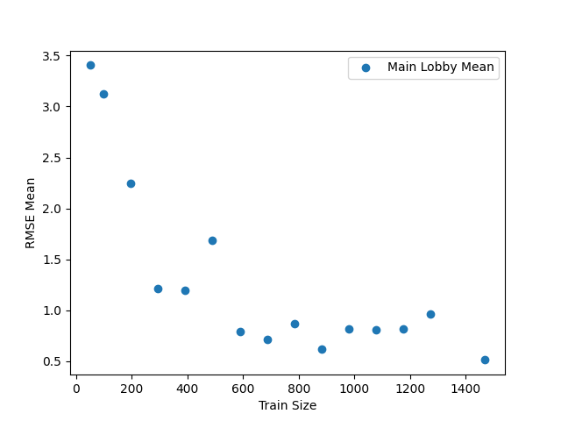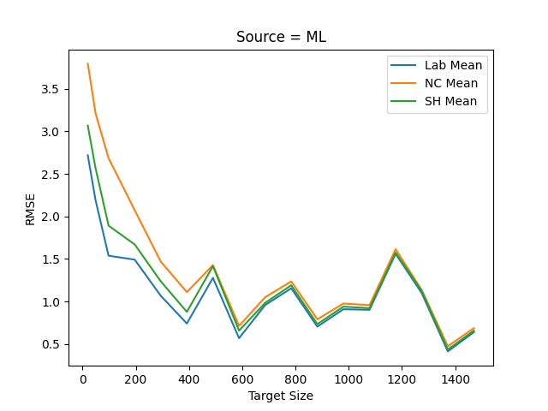

Constant:

* Model
* Training Data
* Source Size = 1470

Testing:

* Target size and recording RMSE result.

Result:

* At the point 588, there was a local minimum. This local minimum is clear throughout the 4 different locations. Unlike last time, the minimum here has a reasonable RMSE.

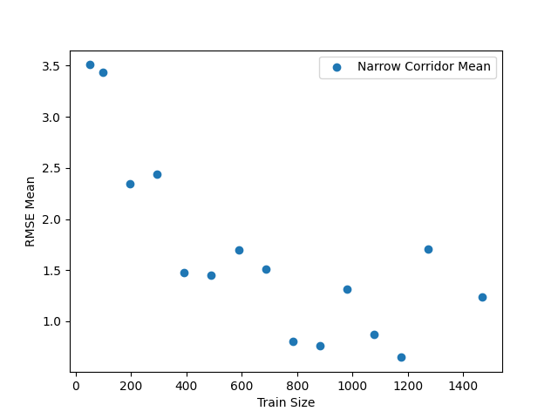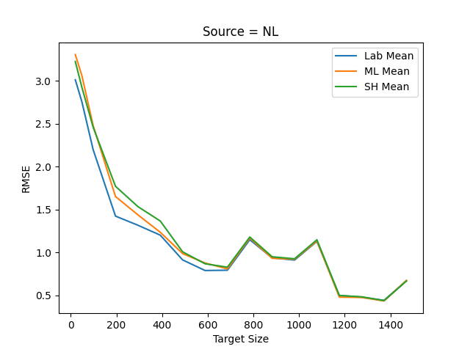

Constant:

* Model
* Training Data
* Source Size = 1470

Testing:

* Target size and recording RMSE result.

Result:

* At around 686 target size, there was a decent point because it has a low RMSDE compared to the next point. However, the major drop occurs at 1176.

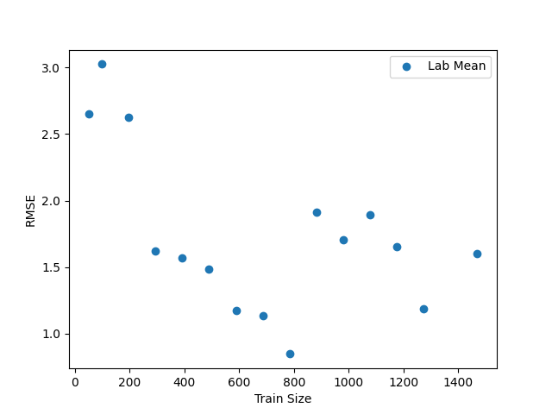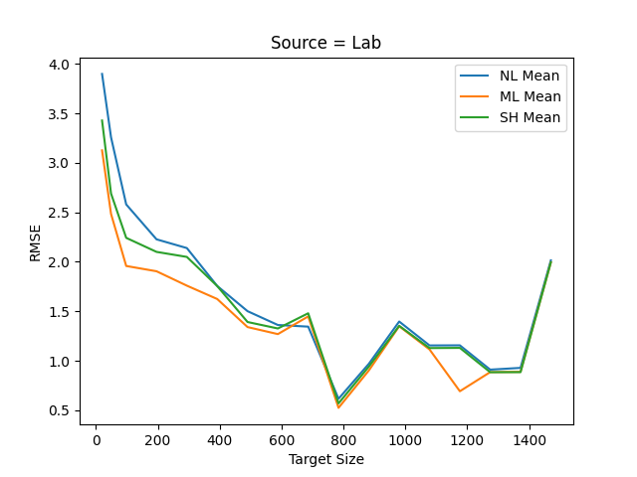

Constant:

·         Model

·         Training Data

·         Source Size = 1470

Testing:

·         Target size and recording RMSE result.

Result:

·         The best point at the graph occurs at 784 target size. In the source values test, the lowest RMSE was also at the same point.

*Conclusion:*

Throughout the graphs, generally, we can see that the lower the RMSE is in the source values, the better the target RMSE will be. Furthermore, if the source values had a clear pattern of descend in the graph, a similar pattern will be notable in the target approach.